Question1

A continuous random variable X has density fX(*x*). If the new random variable Y = 10X-3, what is the new density fY*(y*) in term of fX(*x*) ?

Solution:

The CDF of y could be written as

$$F_{Y}\left(y\right)=p\left(10X-3≤y\right)=p\left(x≤\frac{3+y}{10}\right)=F_{X}\left(\frac{3+y}{10}\right)$$

Then, $f_{Y}\left(y\right)=\frac{d}{dy}F_{Y}\left(y\right)=\frac{1}{10}f_{X}(\frac{3+y}{10}$)

Question2

Lifetime of pigs, dogs, and cats are independent and exponentially distributed. They have means lifetime of 10, 20,and 30 years respectively. If they born simultaneously. What is the probability of pig die first

Solution:

X=1/10e-1/10x Y=1/20e-1/20y Z=1/30e-1/30z

P(x<y<z+x<z<y)= $\int_{0}^{infinite}{\int_{x}^{infinite}{\int_{y}^{infinite}{XYZdzdydx}}}$ + $\int_{0}^{infinite}{\int_{x}^{infinite}{\int_{z}^{infinite}{XYZdydzdx}}}$ =6/11

Question3

A continuous random variable X , if its PDF is given by $fx\left(x\right)=\frac{c}{{1+x}^{2}}$, x ∈ R. Show that $E[X]$ doesn’t exist.

[Solution]:

First find c

$1=\int_{-∞}^{∞}{fx\left(x\right)dx}$ = $\int_{-∞}^{∞}{\frac{c}{{1+x}^{2}}dx}$ = c． $\tan^{-1}{x}|_{-∞}^{∞}$ = c $\left(\frac{π}{2}-\frac{-π}{2}\right)$ = cπ

c = $\frac{1}{π}$

Second calculate E[X]

$\int_{-∞}^{∞}{\left|x\right|fx\left(x\right)dx}$ = $\int_{-∞}^{∞}{\frac{\left|x\right|}{{(1+x}^{2})π}dx}$ = $\frac{2}{π}\int_{0}^{∞}{\frac{x}{{1+x}^{2}}dx}$ = $\frac{1}{π}\ln\left(1+x^{2}\right)|_{0}^{∞}$ = $∞$

Question4

Let X be a continuous random variable with PDF given by

$fx\left(x\right)$ = $\frac{1}{2}e^{-|x|}$,for all x∈R.

If Y= $X^{2}$, find the CDF of Y.

Solution:

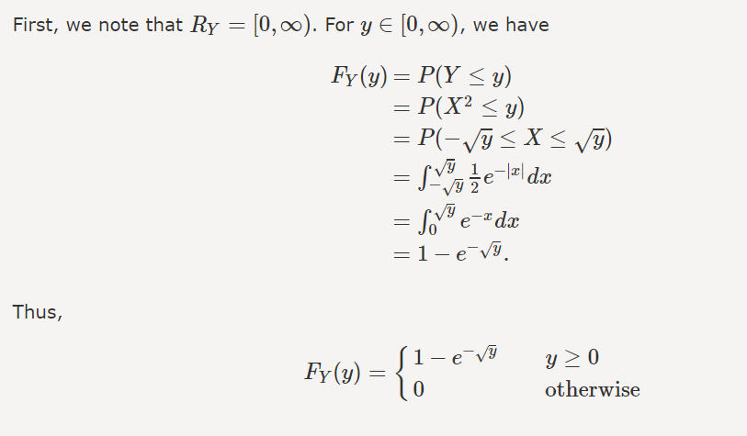

Question 5

A fair coin is ﬂipped repeatedly. What is the probability that the ﬁfth tail occurs before the tenth head?

Solution: 